ALABAMA PUBLIC CHARTER
SCHOOL COMMISSION

PUBLIC CHARTER SCHOOL
RENEWAL CONTRACT
2026

CHARTER CONTRACT FOR CHARTER AUTHORIZERS
PURPOSE
Pursuant to the Alabama School Choice and Opportunity Act (Act 2015-3), the Alabama Public Charter School Commission (Commission) reviews applicable applications; approves or rejects applicable applications; enters into charter contracts with applicants; oversees public charter schools; and decides whether to renew, not renew, or revoke charter contracts. A charter contract is a fixed-term renewable contract between a public charter school and an authorizer (Commission) that outlines the roles, powers, responsibilities, and quantitative and qualitative performance expectations for each party to the contract.
ATTRIBUTION
Some professional entities allow noncommercial re-use of content when proper attribution is provided (e.g., see the COMMISSION’S ACKNOWLEDGEMENT AND ATTRIBUTION shown below). If the Commission elects to use other professional entities’ resources in developing a charter contract and/or any other public charter school document, the Commission must seek the entity’s permission for re-use, then meet its requirements for re-using, acknowledging, and attributing their work back to them.
COMMISSION’S ACKNOWLEDGMENT AND ATTRIBUTION
The Alabama Public Charter School Commission appreciates and acknowledges the Alabama State Department of Education, Public Charter Schools; the National Association of Charter School Authorizers (NACSA) at http://www.qualitycharters.org/; and the Washington State Charter School Commission at http://charterschool.wa.gov/ for granting permission to review, modify, and use content from several of their documents to create this contract for start-up public charter schools in Alabama. By combining content from these entities, the Commission was able to tailor this contract to meet the needs of the Commission pursuant to Act 2015-3.

PUBLIC CHARTER CONTRACT
INSTRUCTIONS
NOTE
This contract is based on key charter contract components required by Act 2015-3. At a minimum, the charter contract must rely on the following information:
- Alabama School Choice and Student Opportunity Act (Act 2015-3)
- Public Charter School Rules and Regulations
- *Principles & Standards for Quality Charter School Authorizing (Most Recent Edition)
- *Taken from National Association of Charter School Authorizers (NACSA)
- Other Alabama State Department of Education Office of Public Charter Schools Resources and Links
2. Commission/Governing Board Acknowledgement and Attribution
- The charter contract must include a statement of acknowledgement and attribution, as discussed in the introduction of this document, if applicable.
3. The charter contract must fully address all components listed under each section listed below.

- Terms and Conditions
- Parties
- Recitals
- Article I: Purpose and Term
- Article II: Definitions
- Article III: School’s Purpose
- Article IV: Governance
- Article V: General Operational Requirements
- Article VI: Enrollment
- Article VII: Tuition and Fees
- Article VIII: Educational Program/Academic Accountability
- Article IX: Financial Accountability
- Article X: School Facilities
- Article XI: Employment
- Article XII: Insurance and Legal Liabilities
- Article XIII: Oversight and Accountability
- Article XIV: Commission’s Rights and Responsibilities
- Article XV: Breach of Contract, Termination, and Dissolution
- Article XVI: Miscellaneous Provisions
- Article XVII: Notice

ALABAMA PUBLIC CHARTER SCHOOL COMMISSION
PUBLIC CHARTER
SCHOOL RENEWAL CONTRACT

CHARTER SCHOOL RENEWAL CONTRACT
FOR THE OPERATION OF EMPOWER COMMUNITY SCHOOL
PARTIES:
Authorizer Name: Alabama Public Charter School Commission
Empower Schools of Alabama

CONTENTS [UPDATE AFTER FINALIZING]
PARTIES 8
Article I: PURPOSE AND TERM 9
Section 1.1 Purpose 9
Section 1.2 Term of Contract 9
Article II: DEFINITIONS 10
Article III: SCHOOL’S PURPOSE 12
Section 3.1 Executive Summary 12
Section 3.2 Mission and Vision 15
Article IV: GOVERNANCE 17
Section 4.1 Governance 17
Section 4.2 Governance Documents 17
Section 4.3 Non-Profit Status 17
Section 4.4 Organizational Structure and Plan 17
Section 4.5 Composition 17
Section 4.6 Change in Status or Governance Documents 17
Section 4.7 Conflicts of Interest 18
Section 4.8 Open Meetings 18
Article V: GENERAL OPERATIONAL REQUIREMENTS 19
Section 5.1 General Compliance 19
Section 5.2 Public School Status 19
Section 5.3 Nonsectarian Status 19
Section 5.4 Access to Individuals and Documents 19
Section 5.5 Ethics ……………………………………………………………………………………………………………. 19
Section 5.6 Record Keeping 19
Section 5.7 Non-Discrimination 19
Section 5.8 Inventories 19
Section 5.9 School Closure/Assets 20
Section 5.10 Transportation 20
Section 5.11 Staff Qualifications 20
Section 5.12 Contracting for Services 20
Section 5.13 Transaction with Affiliates 21
Article VI: ENROLLMENT 22
Section 6.1 Enrollment Policy 22
Section 6.2 Maximum Enrollment 22
Section 6.3 Annual Enrollment Review 22
Section 6.4 Enrollment Plan 22
Section 6.5 Student Records 23
Section 6.6 Student Information System 23
Article VII: TUITION OR FEES 23
Section 7.1 Tuition or School Fees 23
Article VIII: EDUCATIONAL PROGRAM/ACADEMIC ACCOUNTABILITY 24
Section 8.1 Educational Program Terms and Design Elements 24
Section 8.2 Assessments 24
Section 8.3 English Learners 24
Section 8.4 Students with Disabilities 24
Article IX: FINANCIAL ACCOUNTABILITY 25
Section 9.1 Legal and Accounting Compliance 25
Section 9.2 Budget 25
Section 9.3 Annual Budget Statement 25
Section 9.4 School Funds 25
Article X: SCHOOL FACILITIES 26
Section 10.1 Accessibility 26
Section 10.2 Health and Safety 26
Section 10.3 School Location 26
Section 10.4 Inspections 26
Article XI: EMPLOYMENT 27
Section 11.1 No Employee or Agency Relationship 27
Section 11.2 Retirement Plan/Insurance 27
Section 11.3 Background Checks 27
Section 11.4 Immigration 27
Article XII: INSURANCE AND LEGAL LIABILITIES 28
Section 12.1 Insurance 28
Section 12.2 Limitation of Liabilities 28
Section 12.3 Faith and/or Credit Contracts with Third Parties 28
Article XIII: OVERSIGHT AND ACCOUNTABILITY 29
Section 13.1 School Performance Framework 29
Article XIV: COMMISSION’S RIGHTS AND RESPONSIBILITIES 30
Section 14.1 Oversight and Enforcement 30
Section 14.2 Right to Review 30
Section 14.3 Notification of Perceived Problems 30
Section 14.4 Reports by the Commission 30
Article XV: BREACH OF CONTRACT, TERMINATION, AND DISSOLUTION 31
Section 15.1 Breach by the School 31
Section 15.2 Termination by the Commission 31
Section 15.3 Non-Renewal by the Commission 31
Section 15.4 Termination by the School 32
Section 15.5 Dissolution 32
Section 15.6 Disposition of Assets upon Termination or Dissolution 32
Article XVI: MISCELLANEOUS PROVISIONS 33
Section 16.1 Records Retention 33
Section 16.2 Confidential Information 33
Article XVII: NOTICE 34
Section 17.1 Notice 34

PARTIES
This agreement is executed by and between the Alabama Public Charter School Commission (“Authorizer” or “Commission”) and Empower Schools of Alabama (“Governing Board”), for the continued operation of Empower Community School (“School”).

PURPOSE AND TERM

Purpose
This Contract outlines the roles, powers, responsibilities, and performance expectations for the Governing Board’s establishment and operation of Empower Community School, (the “School”), a public charter school. The Governing Board must comply with all of the terms and provisions of this Charter School Contract (“Contract”) and all applicable rules, regulations, and laws.

Term of Contract
On September 14, 2026 the Authorizer approved the renewal application and adopted a resolution extending the School’s Charter Contract for an additional five-year term.

DEFINITIONS
For the purposes of this Contract, and in addition to the terms defined throughout this Contract, each of the following words or expressions, whenever capitalized, shall have the meaning set forth in this section:
ACT. The Alabama School Choice and Student Opportunity Act as enacted as Act Number 2015-3 to provide for public charter schools.
APPLICANT. A group with 501(c)(3) tax-exempt status or that has submitted an application for 501(c)(3) tax-exempt status that develops and submits an application for a public charter school to an authorizer.
APPLICATION. A proposal from an applicant to an authorizer to enter into a charter contract whereby the proposed school obtains public charter school status.
AUTHORIZER. An entity authorized under the Act to review applications, approve or reject applications, enter into charter contracts with applicants, oversee public charter schools, and decide whether to renew, not renew, or revoke charter contracts.
CHARTER CONTRACT. A fixed-term renewable contract between a public charter school and an authorizer that outlines the roles, powers, responsibilities, and quantitative and qualitative performance expectations for each party to the contract.
COMMISSION. The Alabama Public Charter School Commission serving the role as the Authorizer in this Contract.
DEPARTMENT. The Alabama State Department of Education.
EDUCATION SERVICE PROVIDER. An entity with which a public charter school intends to contract for educational design, implementation, or comprehensive management. This relationship shall be articulated in the public charter school application.
FISCAL YEAR. October 1 through September 30.
GOVERNING BOARD. The independent board of a public charter school that is party to the charter contract with the authorizer. A governing board shall have at least 20 percent of its membership be parents of students who attend or have attended the public charter school for at least one academic year. Before the first day of instruction, the 20 percent membership requirement may be satisfied by parents who intend to have their students attend the public charter school.
LOCAL SCHOOL BOARD. A city or county board of education exercising management and control of a city or county local school system pursuant to state law.
LOCAL SCHOOL SYSTEM. A public agency that establishes and supervises one or more public schools within its geographical limits pursuant to state law. A local school system includes a city or county school system.
NATIONALLY RECOGNIZED AUTHORIZING STANDARDS. Standards for high-quality public charter schools issued by the National Association of Charter School Authorizers.
NON–CHARTER PUBLIC SCHOOL. A public school other than a school formed pursuant to the Act. A public school that is under the direct management, governance, and control of a local school board or the state.
PARENT. A parent, guardian, or other person or entity having legal custody of a child.
PUBLIC CHARTER SCHOOL. A public school formed pursuant to the Act.
RESIDENCE. The domicile of the student’s custodial parent.
SCHOOL YEAR. July 1 through June 30.
START–UP PUBLIC CHARTER SCHOOL. A public charter school that did not exist as a non-charter public school prior to becoming a public charter school.
STUDENT. Any child who is eligible for attendance in public schools in the state.
STATE SUPERINTENDENT. The State Superintendent of Education.

SCHOOL’S PURPOSE

Executive Summary
[ADD]

Mission and Vision
[ADD]

GOVERNANCE

Governance
The School shall be governed by its Governing Board in a manner that is consistent with the terms of this Contract so long as such provisions are in accordance with state, federal, and local law. The Governing Board shall have final authority and responsibility for the academic, financial, and organizational performance of the School, the fulfillment of the Contract, and approval of the School’s budgets.
The Governing Board shall be responsible for policy and operational decisions of the School, and, consistent with the terms of this Contract, shall be the employer of school employees. Nothing herein shall prevent the Governing Board from delegating decision-making authority for policy and operational decisions to officers, employees, and agents of the School. However, such delegation will not relieve the Governing Board of its obligations under the law or this Contract, should the School fail to satisfy those obligations.
The Governing Board shall govern the School in a manner that ensures that it will satisfy its legal obligations, including, but not limited to: compliance with all applicable Laws, the Contract, the performance framework and fidelity to the program and policies described and submitted in the Application. This includes the exercise of continuing oversight over the School’s operations. No member of a Governing Board shall have a financial relationship to an education service provider or the staff of the Commission.

Governance Documents
The Governing Board and the School shall maintain legal status and operate in accordance with the terms of the Governance Documents.

Non-Profit Status
A public charter school must be and will be governed by an independent governing board that is, throughout the Term of the Contract, a 501(c)(3) tax-exempt organization.

Organizational Structure and Plan
The School shall implement and follow the organizational plan described in the initial Application.

Composition
The Governing Board at all times shall have at least 20 percent of its members be parents of students who attend or who have attended the School for at least one academic year.

Change in Status or Governance Documents
The Governing Board shall not alter its legal status, restructure, or reorganize without first obtaining written approval from the Commission. The Governing Board shall immediately notify the Commission of any change of its status as a 501(c)(3) tax-exempt organization.

Conflicts of Interest
All members of a governing board shall be subject to the State Ethics Law. Ala. Code § 16-6F-9.
An employee, agent, or representative of an authorizer may not simultaneously serve as an employee, agent, representative, vendor, or contractor of a public charter school of that authorizer. Ala. Code § 16-6F-6.
In no event shall the Governing Board be comprised of voting members a majority of which are directors, officers, employees, agents, or otherwise affiliated with any single entity (with the exception of the School itself or of another charter school) regardless of whether the entity is affiliated or is otherwise partnered with the School. But, this prohibition does not apply to entities whose sole purpose is to provide support to the specific School in question or any of its programs (parent-teacher groups, booster clubs, etc.).
Conflicts of interest may arise at any point during decisions pertaining to business. Conflicts can happen throughout the time employees and officials carry out their roles and responsibilities. Therefore, it is important to the integrity of the Governing Board that staff are aware of the potential for conflicts. Employees and contractors must also be aware of their responsibilities if conflicts are detected, including obligations to report the conflict.

Open Meetings
Starting from the date that this Contract is fully executed, the Governing Board shall be subject to and comply with the Alabama Open Meetings Act and public records laws.

GENERAL OPERATIONAL REQUIREMENTS

General Compliance
The School and the Governing Board shall operate at all times in accordance with all applicable laws, the Contract, and the Commission policies, as may be amended from time to time.

Public School Status
The School is a public school and is part of the public education system of the state. The School shall function as a local educational agency. The School shall be responsible for meeting the requirements of local educational agencies under applicable federal, state, and local laws, including those relating to special education. No private or nonpublic school may establish a public charter school.

Nonsectarian Status
A public charter school shall not include any parochial or religious theme nor shall any public charter school engage in any sectarian practices in its educational program, admissions or employment policies, or operations.

Access to Individuals and Documents
The School shall provide the Commission with access to any individual, documentation, evidence, or information requested by the Commission. The School affirmatively consents to the Commission obtaining information and documents directly from any entity or individual who may possess information or documents relevant to the operation of the school and will sign any releases or waivers required by such individuals or entities. Failure to provide this access by the deadlines imposed by the Commission will be a material and substantial breach of the Contract.

Ethics
All members of the Governing Board and all employees, teachers, and other instructional staff of the School shall be subject to the Alabama Ethics Laws.

Record Keeping
The School shall report enrollment and attendance data to the local school systems of residence in a timely manner. The School shall report such enrollment, attendance, and other counts of students to the Department in the manner required by the Department.

Non-Discrimination
The School shall not discriminate against any person on the basis of race, creed, color, sex, disability, or national origin or any other category that would be unlawful.

Inventories
The School shall maintain a complete and current inventory of all capital assets that cost more than $5,000 and maintain a supplemental inventory of equipment items not classified as capital assets. The School shall update the inventory annually and shall take reasonable precautions to safeguard assets acquired with public funds.
If the Contract is revoked, terminated, non-renewed or surrendered, or the School otherwise ceases to operate, capital assets shall be deemed to be public assets if at least 25 percent of the funds used to purchase the asset were public funds. Public funds include, but are not limited to, funds received by the School, as well as any state or federal grant funds.

School Closure/Assets
In the event of closure of the School for any reason, the Commission shall oversee and work with the closing school to ensure a smooth and orderly closure and transition for students and parents, as guided by the closure protocol. The assets of the School shall be distributed first to satisfy outstanding payroll obligations for employees of the School, then to creditors of the School, and then to the State Treasury to the credit of the Education Trust Fund. If the assets of the School are insufficient to pay all parties to whom the School owes compensation, the prioritization of the distribution of assets may be determined by decree of a court of law.

Transportation
The School may enter into a contract with a school system or private provider to provide transportation to the School’s students. The School shall be responsible for providing students transportation consistent with the plan proposed in the approved application.

Staff Qualifications
The School shall comply with applicable federal laws, rules, and regulations regarding the qualification of teachers and other instructional staff. It is the intent of Empower Community School to hire highly qualified teachers and staff who are committed to the high academic and other expectations of the School.

Contracting for Services
Nothing in this Contract shall be interpreted to prevent the School from entering into contracts or other agreements with a school district, educational service district, or other public or private entity for the provision of real property, equipment, goods, supplies, and services, related to the operation of the School consistent with the law and the terms of this Contract. However, all capital assets purchased from public funds of the School shall become property of the School unless the Commission specifically approves an agreement or contract not subject to this provision.
If the School chooses to purchase services from a local school system, such as transportation-related or lunchroom-related services, the School shall execute an annual service contract with the local school system, separate from the charter contract, stating the mutual agreement of the parties concerning any service fees to be charged to the School.
If the School intends to contract with an education service provider for substantial education services, management services, or both types of services, the School shall provide to the Commission all of the following at least 90 days before the effective date of the proposed contract:

Evidence of the education service provider’s success in serving student populations similar to the targeted population, including demonstrated academic achievement as well as successful management of nonacademic school functions, if applicable.

A draft agreement setting forth the proposed duration of the service contract; roles and responsibilities of the Governing Board, the School staff, and the education service provider; scope of services and resources to be provided by the education service provider; performance evaluation measures and timelines; compensation structure, including clear identification of all fees to be paid to the education service provider; methods of contract oversight and enforcement; investment disclosure; and conditions for renewal and termination of the contract. See Attachment to Application #29, also attached at the end of this contract.

Disclosure and explanation of any existing or potential conflicts of interest between the School or the Governing Board and the education service provider or any affiliated business entities. See Attachment to Application #30.

Transaction with Affiliates
The School shall not, directly or indirectly, enter into or permit to exist any transaction (including the purchase, sale, lease, or exchange of any property or the rendering of any service) with any affiliate of the School, any member past or present of the Governing Board, or any past or present employee of the School (except in their employment capacity), or any family member of the foregoing individuals, unless:

The terms of the transaction do not violate the Schools’ Code of Ethics and Conflict of Interest Policy or the terms of this Contract.

The terms of such transaction (considering all the facts and circumstances) are no less favorable to the School than those that could be obtained at the time from a person that is not such an affiliate, member, employee, or an individual related thereto.

The involved individual recuses him- or herself from all Governing Board discussions and does not vote on or decide any matters related to such transaction.

The Governing Board discloses any conflicts and operates in accordance with a conflict of interest policy that has been approved by the Commission.
“Affiliate” as used in this section means a person who directly or indirectly owns or controls, is owned or controlled by, or is under common ownership or control with, another person. Solely for purposes of this definition, “owns,” “is owned,” and “ownership” mean ownership of an equity interest, or the equivalent thereof, of ten percent or more, and the term “person” means an individual, partnership, committee, association, corporation or any other organization or group of persons.

ENROLLMENT

Enrollment Policy
The School shall comply with applicable law and the enrollment policy found in Section 5(a)(1-10) of the Act.

Maximum Enrollment
The capacity of the public charter school shall be determined annually by the Governing Board of the School, and submitted for formal approval by the Authorizer, in conjunction with the Commission and in consideration of the School’s ability to facilitate the academic success of its students, achieve the other objectives specified in the charter contract, and ensure that its student enrollment does not exceed the capacity of its facility or site.

Annual Enrollment Review
As necessary, the maximum enrollment of the School will be adjusted annually by the Governing Board, and submitted for formal approval by the Authorizer, in consultation with the Commission and with consideration of the School’s ability to facilitate the academic success of its students, achieve the objectives specified in the Contract, and assure that its student enrollment does not exceed the capacity of its facility.

Enrollment Plan
The anticipated and maximum enrollment are provided in the following table:
[ENTER CHART]

Student Records
The School shall maintain student records in the same manner as non-charter public schools.

Student Information System
The School will utilize the same student information system and procedures as non-charter public schools.

TUITION OR FEES

Tuition or School Fees
The School staff shall not charge tuition and may only charge such fees as may be imposed on other students attending charter public schools in the state. Each fee must be approved by the Governing Board.
Anticipated fees are detailed in the following list:
[ADD FEES]

EDUCATIONAL PROGRAM/ACADEMIC ACCOUNTABILITY

Educational Program Terms and Design Elements
The School shall implement, deliver, support, and maintain the essential design elements of its educational program as described in its Application.

Assessments
The School shall be subject to the statewide end-of-year annual standardized assessment tests, systems, and procedures as are required of non-charter public schools. The School shall comply with all assessment protocols and requirements as established by the Department, maintain test security, and administer tests consistent with all Department requirements.

English Learners
The School shall at all times comply with all applicable laws governing the education of English learners including, but not limited to, the Elementary and Secondary Education Act (ESEA), Title VI of the Civil Rights Act of 1964, the Equal Educational Opportunities Act of 1974 (EEOA), and subsequent federal laws. The School shall provide resources and support to English learners to enable them to acquire sufficient English language proficiency to participate in the mainstream English language instructional programs. The School shall employ and train teachers to provide appropriate services to English learners. The School must implement, deliver, support, and maintain an education program that provides all the legally required education and services to English learners.

Students with Disabilities
The School shall provide services and accommodations to students with disabilities as set forth in the Application and in accordance with any relevant policies thereafter adopted, as well as with all applicable provisions of the Individuals with Disabilities Education Act (20 U.S.C. § 1401 et seq.), the Americans with Disabilities Act (42 U.S.C. § 12101 et seq.), Section 504 of the Rehabilitation Act of 1973 (29 U.S.C. § 794), and all applicable regulations promulgated pursuant to such federal laws. This includes providing services to attending students with disabilities in accordance with the individualized education program (“IEP”) recommended by a student’s IEP team. The School shall also comply with all applicable federal and state laws, rules, policies, procedures, and directives regarding the education of students with disabilities.

FINANCIAL ACCOUNTABILITY

Legal and Accounting Compliance
The School will report financial accounting information (including, but not limited to, payroll, budgeting, general fixed assets, etc.) to the State Department of Education in a format that meets the specifications of the Department.
The School shall adhere to generally accepted accounting principles, document and follow internal control procedures, and annually engage an independent certified public accountant to do an independent audit of the school’s finances. The School shall file a copy of each audit report and accompanying management letter to the Commission and the Department by June 1 following the end of the fiscal year. The audits shall meet the same requirements as those required of local school systems.
The Department may withhold state or federal funds from the School if the School does not provide financial and budget reports, disclosures, certifications, and forms to the Department in a timely manner or in the format required by the Department or other state or federal agencies. The School will allow the Department and other government agencies to inspect records and monitor compliance with state, federal, and local laws and regulations applicable to the School. The School shall allow representatives of the Commission to inspect records at any time.
The School is subject to Alabama laws for public records including the Alabama Department of Archives and History record retention requirements for local school boards and the rights of citizens to view the public records that are not restricted from disclosure.
The School will utilize the same financial accounting system and procedures as non-charter public schools. The School shall utilize the financial accounting and payroll software programs used by non-charter Alabama public schools. The School will post monthly financial reports and check registers on the School’s website within forty-five (45) days of the end of each month. Likewise, the School will post an annual financial report on the School’s website within forty-five (45) days of the end of the fiscal year.

Budget
The Commission may require the School to revise start-up and five-year budgets included in the charter school application.

Annual Budget Statement
The Governing Board of the School shall submit its annual budget to the Authorizer for review and shall adopt an annual budget each fiscal year. The Governing Board of the School shall adopt an annual budget statement that describes the major objectives of the educational program and manner in which the budget proposes to fulfill such objectives.

School Funds
The funds of the School shall be maintained in a qualified public depository subject to the requirements of the Security for Alabama Funds Enhancement Act (SAFE).

SCHOOL FACILITIES

Accessibility
The School’s facilities shall conform to the Americans with Disabilities Act and other applicable laws and requirements for public school facilities.

Health and Safety
The School facilities shall meet all laws governing health, safety, and occupancy and fire code requirements and shall be of sufficient size to safely house the anticipated enrollment.

School Location
The address of the School is 751 Academy Drive, Bessemer, Alabama 35022. Any additions or change in the location of the School, including modulars, must be deemed acceptable by the Commission. Current modulars and construction of modulars already approved by the Commission do not have to be reapproved.

Inspections
The Commission will have access at all reasonable times and frequency to any facility owned, leased or utilized in any way by the School for purposes of inspection and review of the School’s operation and to monitor the School’s compliance with the terms of this Contract and all applicable laws. These inspections may be announced or unannounced as deemed appropriate by the Commission, or its designee, in the fulfillment of its oversight responsibilities.

EMPLOYMENT

No Employee or Agency Relationship
Neither the School, its employees, agents, nor contractors are employees or agents of the Commission. The Commission or its employees, agents, or contractors are not employees or agents of the School. None of the provisions of this Contract will be construed to create a relationship of agency, representation, joint venture, ownership, or control of employment between the Parties other than that of independent Parties contracting solely for the purpose of effectuating this Contract.

Retirement Plan/Insurance
The Governing Board of the School has voted to participate in the Teachers’ Retirement System and Public Education Employees’ Health Insurance Plan.

Background Checks
Public charter school employees are subject to the same fingerprint-based criminal history background checks that traditional public school employees are under the Alabama Child Protection Act of 1999, as amended. Generally speaking, a criminal history background information check shall be conducted on all applicants and contractors seeking positions with, and on all current employees of, the School, who have unsupervised access to children.

Immigration
The Governing Board and the School shall meet the requirements of the Beason-Hammon Taxpayer and Citizen Protection Act (Act No. 2011-535). The School may not receive state funds before filing the School’s E-Verify Memorandum of Understanding with the Department.

INSURANCE AND LEGAL LIABILITIES

Insurance
The School will maintain adequate insurance necessary for the operation of the School, including, but not limited to, property insurance, general liability insurance, workers’ compensation insurance, unemployment compensation insurance, motor vehicle insurance, errors and omissions insurance, and all other insurance intended to cover the Governing Board, School, and its employees. The School will maintain fidelity bonds on all School employees.

Limitation of Liabilities
In no event will the State of Alabama, or its agencies, officers, employees, or agents, including, but not limited to, the Commission, be responsible or liable for the debts, acts, or omissions of the School, its officers, employees, or agents.

Faith and/or Credit Contracts with Third Parties
The School shall not have authority to extend the faith and credit of the Commission or the State of Alabama to any third party and agrees that it will not attempt or purport to do so. The School acknowledges and agrees that it has no authority to enter into a contract that would bind the Commission or the State of Alabama and agrees to include a statement to this effect in each contract or purchase order it enters into with third parties.

OVERSIGHT AND ACCOUNTABILITY

School Performance Framework

The performance framework is attached as Attachment 1.

COMMISSION’S RIGHTS AND RESPONSIBILITIES

Oversight and Enforcement
The Commission shall have the authority to manage, supervise, and enforce this Contract. It will oversee the School’s performance under this Contract and hold the School accountable to performance of its legal and contractual obligations, including fulfillment of its Performance Framework. The Commission may take any action necessary to enforce its authority including, but not limited to, requiring the development and implementation of a corrective action plan, sanctions, non-renewal, revocation, or termination of this Contract.

Right to Review
The Commission is an independent state entity with oversight and regulatory authority over the School that it authorizes. Upon request, the Commission, or its designee, shall have the right to review all records created, established, or maintained by the School in accordance with the provisions of this Contract, Commission policies and regulations, or federal and state laws and regulations. This right shall be in addition to the Commission’s right to require the School to submit data and other information to aid in the Commission’s oversight and monitoring of the School as provided under this Contract and governing law. When the request is for on-site inspection of records, the Commission shall be granted immediate access. If the request is for reproduction of records, then the Commission will include a timeframe in which the records must be provided and the School must adhere to this timeframe.
This information, regardless of the form in which it is disclosed, will be used by the Commission, and its authorized representatives, to satisfy its obligations to audit, evaluate, and conduct compliance and enforcement activities relative to the School. The parties agree to cooperate with each other to ensure that any disclosure of personally identifiable information from education records to the Commission or its authorized representatives for such purposes complies with FERPA.

Notification of Perceived Problems
Any notification of perceived problems by the Commission about unsatisfactory performance or legal compliance will be provided within reasonable timeframes considering the scope and severity of concern. Every effort will be made to allow the School a reasonable opportunity to respond and remedy the problem unless immediate revocation is warranted.

Reports by the Commission
The Commission shall submit to the State Board of Education a publicly accessible annual report within 60 days after the end of each fiscal year summarizing all of the items required in the Act. The School must provide any information requested by the Commission to complete required reports.

BREACH OF CONTRACT, TERMINATION, AND DISSOLUTION

Breach by the School
Violation of any material provision of this contract may, in the discretion of the Commission, be deemed a breach and be grounds for corrective action up to and including revocation or nonrenewal of this Contract. In making this determination, the Commission will consider the underlying facts and circumstances including, but not limited to, the severity of the violation as well as the frequency of violations. Material provisions include, but are not limited to, provisions imposing a requirement to comply with the Commission rules and policies and all applicable laws related to the health, safety, and welfare of students.

Termination by the Commission
This Contract may be terminated after written notice to the School and the charter revoked by the Commission for any of the following reasons:

A material and substantial violation of any of the terms, conditions, standards, or procedures set forth in the Contract.

Failure to meet generally accepted standards of fiscal management.

Failure to provide the Commission with access to information and records.

Substantial violation of any provision of applicable law.

Failure to meet the goals, objectives, content standards, performance framework, applicable federal requirements, or other terms identified in the Contract.

Failure to attain the minimum state proficiency standard for public charter schools in each year of their operation and over the charter term.

Bankruptcy, insolvency, or substantial delinquency in payments, of the School.

Discovery that the Applicant submitted inaccurate, incomplete, or misleading information in its Application or in response to a Commission’s request for information or documentation.

School’s performance falls in the bottom quartile of schools on the State Board of Education’s accountability index.

Non-Renewal by the Commission
The Commission may non-renew a public charter school if the Commission determines that the public charter school did any of the following or otherwise failed to comply with this act:

Commits a material and substantial violation of any of the terms, conditions, standards, or procedures required under the Act or the Contract.

Fails to meet the performance expectations set forth in the Contract.

Fails to meet generally accepted standards of fiscal management.

Substantially violates any material provision of law from which the School was not exempted.

Fails to meet the performance expectations set forth in the Contract, or fails to attain the minimum state proficiency standard for public charter schools (minimum state standard) in each year of its operation and over the charter term, unless the School demonstrates and the Commission affirms, through formal action of its Governing Board, that other indicators of strength and exceptional circumstances justify the continued operation of the School.

Termination by the School
Should the School choose to terminate this Contract before the end of the Contract term, it must provide the Commission with notice of the decision immediately after it is made, but no later than ninety (90) days before the closure of the school year. Notice shall be made in writing to the Commission. The School must comply with the Commission’s termination protocol.

Dissolution
Upon termination of this Contract for any reason by the School, upon expiration of the Contract, or if the School should cease operations or otherwise dissolve, the Commission shall oversee and work with the School to ensure a smooth and orderly closure and transition for students and parents, as guided by the Commission’s closure protocol; provided, however, that in doing so the Commission will not be responsible for and will not assume any liability incurred by the School under this Contract. The Governing Board and School personnel shall cooperate fully with the winding up of the affairs of the School. The School’s obligations for following a termination protocol and winding up of the affairs of the School shall survive the term of this contract.

Disposition of Assets upon Termination or Dissolution
The assets of the School shall be distributed first to satisfy outstanding payroll obligations for employees of the School, then to creditors of the School, and then to the State Treasury to the credit of the Education Trust Fund. If the assets of the School are insufficient to pay all parties to whom the School owes compensation, the prioritization of the distribution of the assets may be determined by decree of a court of law.

MISCELLANEOUS PROVISIONS

Records Retention
School records shall be maintained in accordance with all applicable state and federal document and record retention requirements. If any litigation, claim, or audit is started before the expiration of an applicable document retention period, the records shall be retained until all litigation, claims, or audit findings involving the records have been resolved.

Confidential Information
The parties acknowledge and agree that the education records of students enrolled in a School are governed by the requirements of the Family Educational Rights and Privacy Act (“FERPA”), 20 U.S.C. § 1232g, and its corresponding regulations. The parties will safeguard personally identifiable information from education records in their possession by developing and adhering to a Data Governance Policy that safeguards against unauthorized access or disclosure of such records in accordance with said law and applicable Department policies.

NOTICE

Notice
Any change in address shall be immediately given to the other party in writing. Any notice that is undeliverable due to change of address without proper notification to the other party will be deemed received on the date delivery to the last known address was attempted.
If a notice is received on a weekend or on a national or Alabama state holiday, it shall be deemed received on the next regularly scheduled business day.
IN WITNESS WHEREOF, the Parties have executed this Contract.
APPROVED BY A QUORUM OF THE COMMISSION
signed this
Chair, Alabama Public Charter School Commission
signed this
[Title]
Empower Community School

APPENDICES
Attachment 1: Student Performance Framework

Attachment 2: Statement of Assurances

ATTACHMENT 1: SCHOOL PERFORMANCE FRAMEWORK


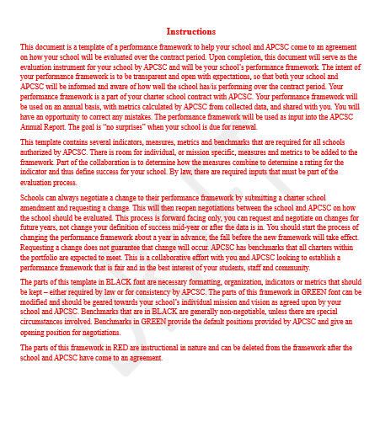

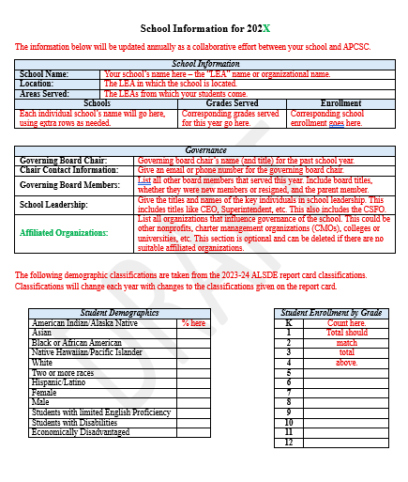

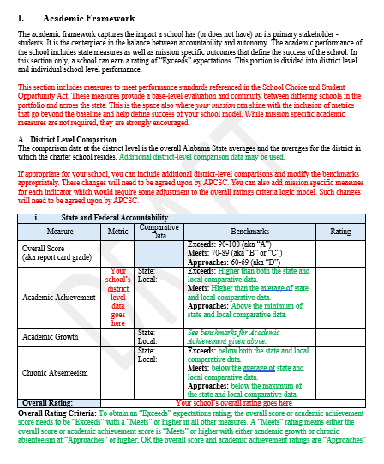

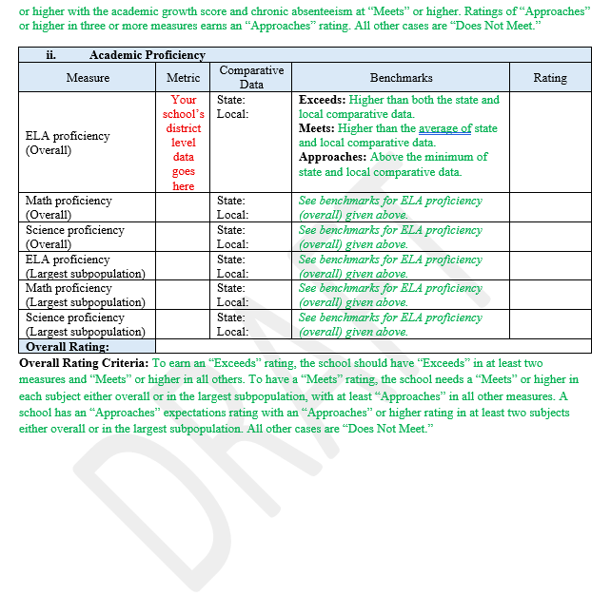

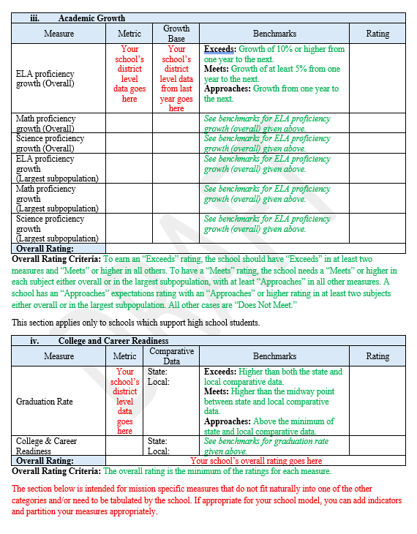

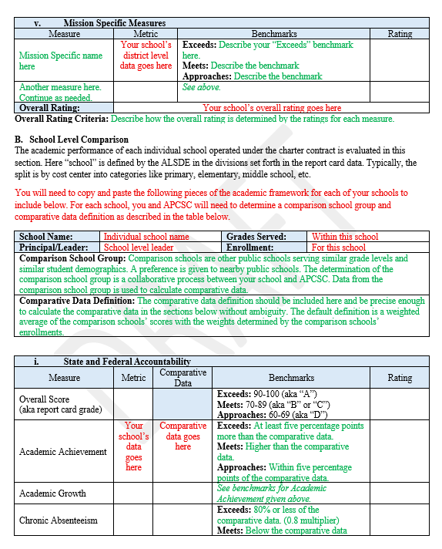

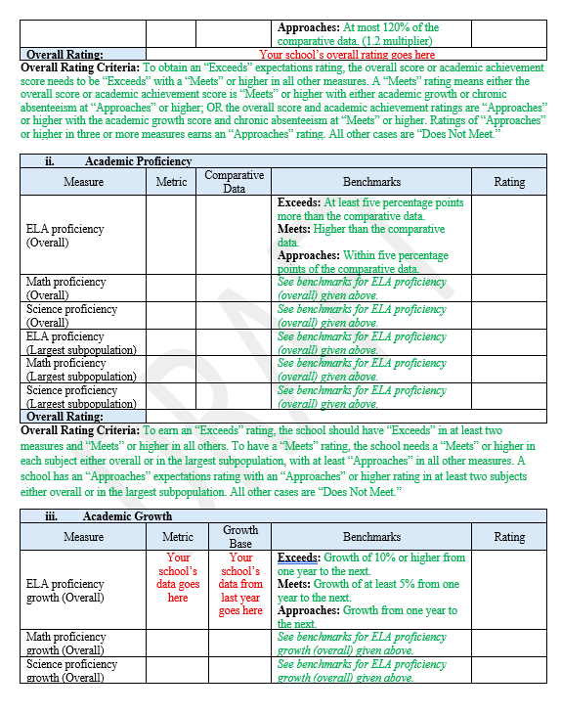
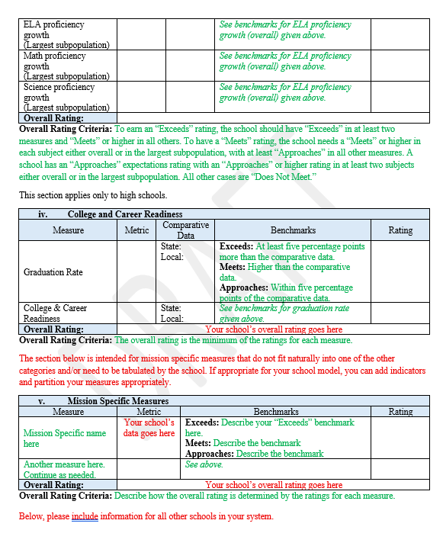

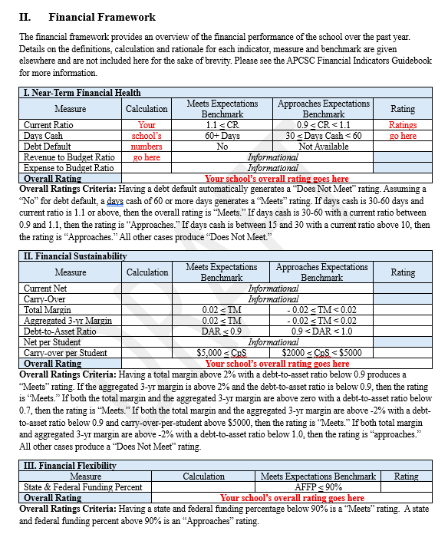

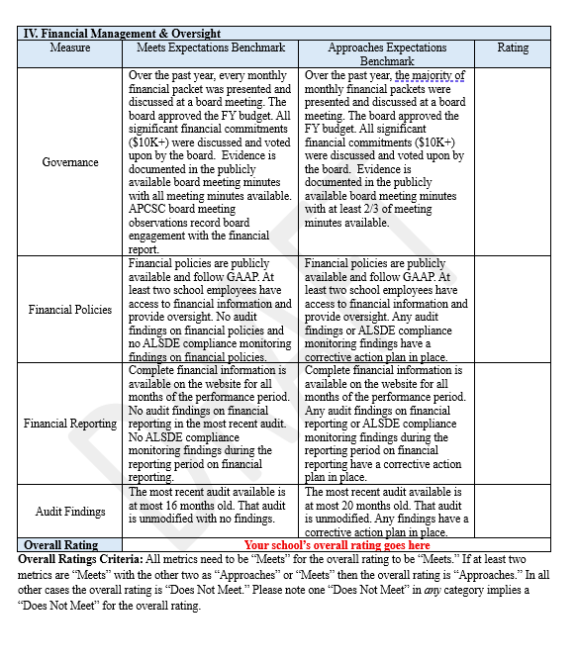

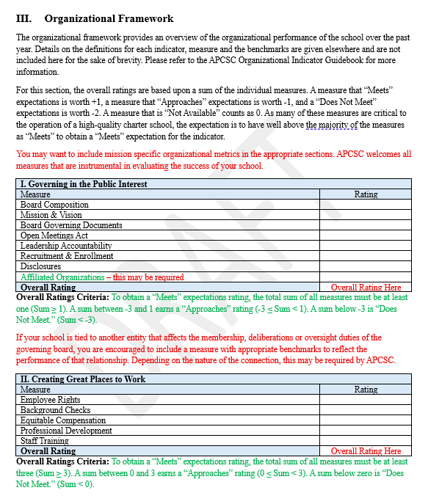

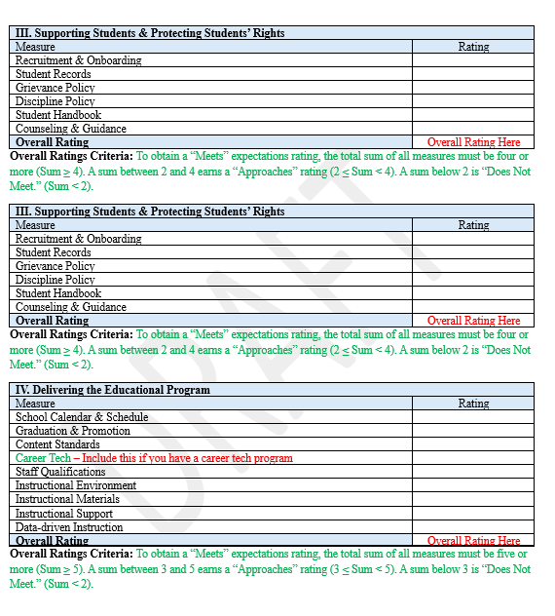

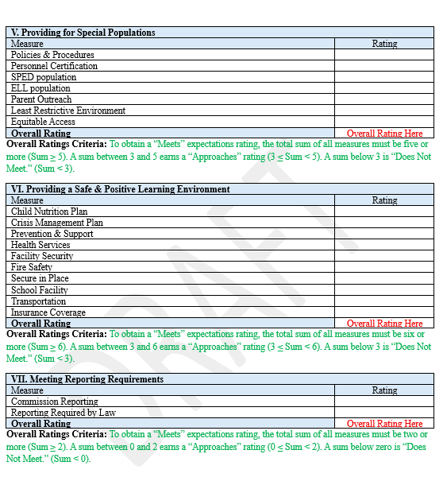

ATTACHMENT 2: STATEMENT OF ASSURANCES

STATEMENT OF ASSURANCES
This Statement of Assurances must be signed by a duly authorized representative of the charter school.
As the duly authorized representative of the school, I hereby certify under the penalty of perjury that all information and statements submitted for or on behalf of Empower Community School are accurate and true to the best of my knowledge and belief; and further, I certify and assure that:
- The School shall have a fully independent governing board that will exercise autonomy in all matters, to the extent authorized by the Act.
- The School has tax exempt status under section 501(c)(3) of the Internal Revenue Code of 1986 (26 U.S.C. § 501(c)(3)), is not a sectarian or religious organization, and shall be operated according to the terms of the renewal charter contract executed with the Alabama Public Charter School Commission.
- The School shall function as a local education agency under applicable federal laws and regulations, shall be responsible for meeting, and shall meet the requirements of local education agencies and public schools under those federal laws and regulations, including but not limited to:
  - Compliance with the individuals with disabilities education improvement act (IDEA, 20 U.S.C. § 1401 et seq.).
  - Compliance with the federal educational rights and privacy act (FERPA, 20 U.S.C. § 1232g).
  - Compliance with the elementary and secondary education act (ESEA, 20 U.S.C. § 6301 et seq.).
  - Compliance with requirements that ensure a student’s records, and, if applicable, a student’s individualized education program, will follow the student, in accordance with applicable federal and state law.
  - Compliance with the Every Student Succeeds Act, including but not limited to, provisions on school prayer, the Boy Scouts of America Equal Access Act, the Armed Forces Recruiter Access to Students and Student Recruiting Information, the Unsafe School Choice Option and assessments.
  - Compliance with Title IX of the Education Amendments of 1972 (20 U.S.C. § 1681).
  - Compliance with Section 504 of the Rehabilitation Act of 1973 (29 U.S.C. § 794).
  - Compliance with Title II of the Americans With Disabilities Act of 1990 (42 U.S.C. § 12101).
- The School shall hire, manage, and discharge any charter school employee in accordance with state laws and the School’s charter contract.
- The School shall receive and disburse funds solely in accordance with the purposes of the charter school.
- To the extent it enters into contracts with any school district, educational service district, or other public or private entity for the provision of real property, equipment, goods, supplies, and services, including educational instructional services and including for the management and operation of the charter school, the School shall do so to the same extent as other non-charter public schools, as long as the School’s governing board maintains oversight authority over the charter school.
- The School shall not enter into any contracts for management operation of the charter school except with nonprofit organizations.
- To the extent it enters into contracts with other entities regarding real property, the School shall include provisions regarding the disposition of the property if the charter school closes, or if the charter contract is revoked or not renewed.
- To the extent it issues secured and unsecured debt, including pledging, assigning, or encumbering its assets to be used as collateral for loans or extensions of credit to manage cash flow, improve operations, or finance the acquisition of real property or equipment, the School shall not pledge, assign, or encumber any public funds received or to be received.
- The School shall ensure that no debt incurred by the School is a general, special, or moral obligation of the state or any other political subdivision or agency of the state.
- The School shall not pledge either the full faith and credit or the taxing power of the state or any political subdivision or agency of the state for the payment of the debt.
- To the extent it solicits, accepts, and administers for the benefit of the charter school and its students, gifts, grants, and donations from individuals or public or private entities, the School shall not solicit, accept, and administer any such gifts, grants or donations from sectarian or religious organizations and shall not accept any gifts or donations the conditions of which violate state laws.
- The School shall issue diplomas to students who meet state high school graduation requirements established by the Department even though the charter school governing board may establish additional graduation requirements.
- The School shall not levy taxes or issue tax-backed bonds and shall not acquire or attempt to acquire property by eminent domain.
- The School shall operate according to the terms of its charter contract and the Act.
- The School shall comply with local, state, and federal health, safety, parents’ rights, civil rights, and nondiscrimination laws applicable to school districts and to the same extent as school districts.
- The School shall provide basic education, including instruction in the essential academic learning requirements and shall participate in the statewide student assessment system.
- The School shall employ certified instructional staff as required by Federal program regulations.
- The School shall adhere to generally accepted accounting principles and be subject to financial examinations and audits as determined by the Department, including annual audits for legal and fiscal compliance.
- The School shall comply with the open public meetings act and public records requirements.
- The School shall be subject to and comply with all legislation governing the operation and management of charter schools.
- The School shall comply with all state statutes and rules made applicable to the charter school in the school’s charter contract.
- The School shall not engage in any sectarian practices in its education program, admissions or employment policies, or operations.
- The School shall be subject to the supervision of the State Superintendent and the State Board of Education, including accountability measures, to the same extent as non-charter public schools, except as otherwise expressly provided by law.
- The School shall not limit admission on any basis other than age group, grade level, or capacity and must enroll all students who apply within these bases and shall be open to any Alabama student regardless of his or her location of residence.
- The School shall not charge tuition but may charge fees for participation in optional extracurricular events and activities in the same manner and to the same extent as do non-charter public schools.
- If capacity is insufficient to enroll all students who apply to the charter school, the School must select students through a lottery as provided in the Act.
- The School’s Governing Board shall annually determine the capacity of the School in consultation with the Commission and with consideration of the School’s ability to facilitate the academic success of its students, achieve the objectives specified in the charter contract, and assure that its student enrollment does not exceed the capacity of its facility.
- The School shall comply with all health and safety laws, rules, and regulations of the federal, state, county, region, or community that may apply to its facilities and property.
- The School has disclosed any real, potential, or perceived conflicts of interest that could impact the approval or operation of the School.
- The School shall comply with, and fully participate in, any activity by the Commission that the Commission deems necessary for it to monitor, engage in oversight, and/or engage in corrective action.
- The School shall comply with any corrective actions or sanctions imposed upon it by the Commission.
- The School shall comply with all renewal and nonrenewal actions required of it by the Commission or by law.
- The School shall comply with any nonrenewal of termination actions imposed by the Commission.
- The School shall report student enrollment in the same manner and based on the same definitions of enrolled students and annual average full-time equivalent enrollment as other public schools.
- The School shall comply with applicable reporting requirements to receive state or federal funding that is allocated based on student characteristics.
- The School shall, at all times, maintain all necessary and appropriate insurance coverage.
- The School shall indemnify and hold harmless the Commission and its officers, directors, agents, and employees, and any successors and assigns from any and all liability, cause of action, or other injury or damage in any way relating to the School or its operation.
39. The School affirms that it shall in all respects comply with the requirements of Ala. Code § 41-1-91, et seq. that prohibits public schools from engaging in specific actions related to diversity, equity, and inclusion.
EMPOWER COMMUNITY SCHOOL
NAME OF SCHOOL
___
SIGNATURE OF DULY AUTHORIZED REPRESENTATIVE DATE

NAME OF DULY AUTHORIZED REPRESENTATIVE

